**CHAPTER 1**

**1.1 INTRODUCTION**

The project Auto UI Code Generation using AI, takes a handwritten image of the front end design required as input to provide the output on a virtual screen with its respective html code.

Artificial intelligence (AI) is the simulation of human intelligence processes by machines, especially computer systems. These processes include learning, reasoning and self-correction. We use Machine Learning which is a subset of Artificial Intelligence to do the job of a human in identifying the various html elements and generating the respective html code.

The project uses Machine Learning model to perform object detection. The model is trained to identify basic html elements like image, text box, button, checkbox, radio button and drop down list. The object detection model identifies the html elements and the position of each element to generate the html code. Handwriting analysis is also done to detect the text to be displayed on the html page. The html code generated is given as output to the user.

The project involves the development of a website where the user can use as an interface to give input and get the respective html code. It also involves the development of API’s that can be used by Twilio so that the user can use WhatsApp as an interface instead of the website.

Each user has an account and the user can store all his previous templates on the database that he can reuse for his future implementation. The code generated as output can also be edited by the user before downloading and saving on the database.

**1.2 MOTIVATION**

HTML is extremely fun to write with, it is very easy to learn and therefore gives the power to create any website design. As a matter of fact this is true for any front end designing. But sometimes designing a web page or any front end development to make it look attractive is quite a task. For some people front end design can be daunting, where they would be able to get the functionalities right but not  be able to make it look pretty.

This is where the project **Auto UI Code Generation using AI** can be used where the user could physically draw the user interface he wishes to display and the system could intelligently generate the same on an actual visual screen and also provide the HTML code for it. The idea is to try to do as little as possible when we build the future web. This isn’t a rationalization for laziness or shirking responsibility nor it is a suggestion that we build bland, homogeneous sites and apps that sacrifice all nuance or spark to the Greater Good of total compatibility. Instead, it is an appeal for simplicity and elegance: putting commonality first, approaching differentiation carefully, and advocating for consistency in the creation and application of web standards. So our project comes into picture for any backend developer who wishes to develop a simple front end design without having to know any advanced functionalities of  the front end development.

**1.3 PROBLEM STATEMENT**

The project aims to help the user in the front end development where the user could physically draw the user interface as he wishes to display and the system could intelligently generate the same on an actual visual screen and also provide the respective front end codes.

In the project an image is given as an input that is analyzed to identify different elements in the image and provide its virtual representation and respective HTML or XML codes.

The design created by each user is stored on the firebase in the respective user’s account, this way the user could reuse the designs created. The advancement to the proposed system would be where the user could use a video feed to simultaneously generate the user interface as and when the users draws something in the video feed.

**1.4 OBJECTIVES**

Intelligently generate the user interface on an actual visual screen and also provide the respective front end codes from the physically drawn design by the user.

* Analysis of the structure of given html sketch physically draw.
* Identify the html elements.
* Get the location of the html elements relative to the screen.
* Handwriting Analysis to get the text to be displayed on the screen.
* A website which can:
  + Build HTML code from the structure.
  + Building Android XML code from the same structure.
  + Using Image or Live Video as Input from the user.
* API built using flask and integrated with Twilio and DialogFlow for:
  + Using WhatsApp messaging where the user can send the sketch which results in a website with the code.
* Edit option for the user to edit the genrated code and simultaneously view its output.
* Design of database to store personal information of each user.
* The database must also store the previously designed pages, for future reuse.
* Firebase storage to upload the created User Interface.

**1.5 SUMMARY**

 In the project Auto UI Code Generation using AI an image or video feed is given as input either to the website that is developed or using WhatsApp. Twilio and Dialog Flow is used to provide the input to the API’s developed. The image taken as input is provided to the Machine Learning model where object detection takes place to identify the html

elements and the coordinates of those elements respectively. Handwriting analysis is done to analyse the text that need to be displayed in the html page. Once these processes are done, the front end and its respective code is generated. This code is sent as the output on the website or through WhatsApp to the user. The user can further edit this code if required and store it in a database for future use.

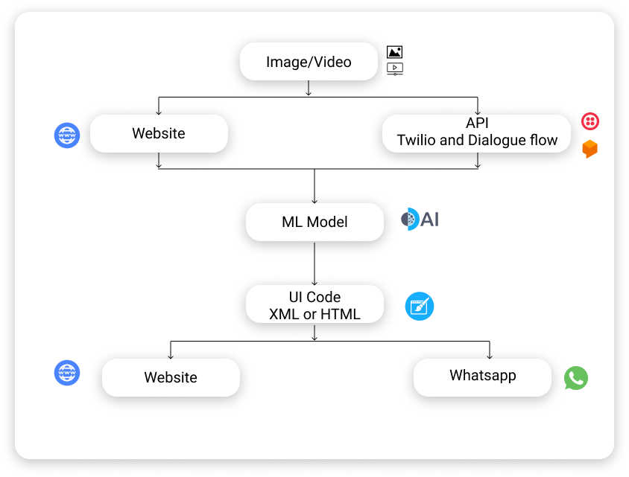

Fig. Working flow of the project

Each user needs to have a seperate account. The details of these users will be stored in database, i.e., Firebase. The pages designed by the user is stored in the database as a file and image. These designs can be re-used with or without editing by the user.